Eric Olsen Donated Hexon Terrain
The terrain listed here was donated by Eric Olsen for CMH members to use at club events. If you would like to use it at a club event please email the club officers to arrange to have it available at the Club. Each of the hexes are 4in. in size. For terrain examples please visit the Kallistra website or check online. For a 6’x 4’ table 36 of the large 6 hex blocks are needed. For an 8’x 5’ table 60 of the large 6 hex block are needed. As you will see, we have considerably more than that.
Thank you Eric for your terrain donation, we hope our CMH members will enjoy using it.

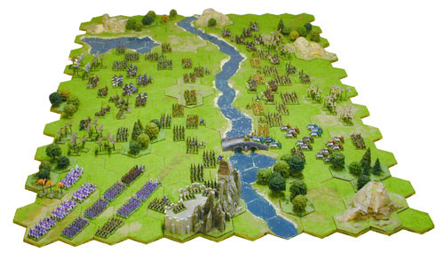
The terrain listed is as follow:

Sea hexes
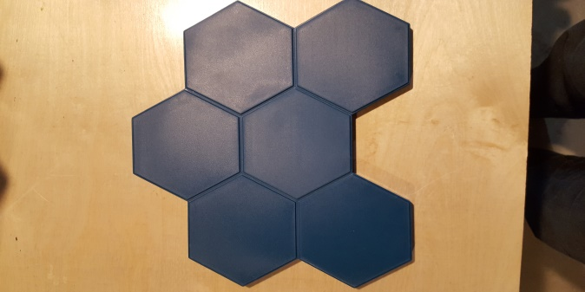 | 6 Hex blocks – 84 pieces
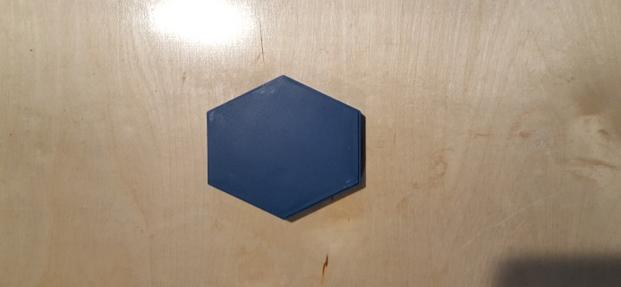 | 1 Hex Blocks – 40 pieces
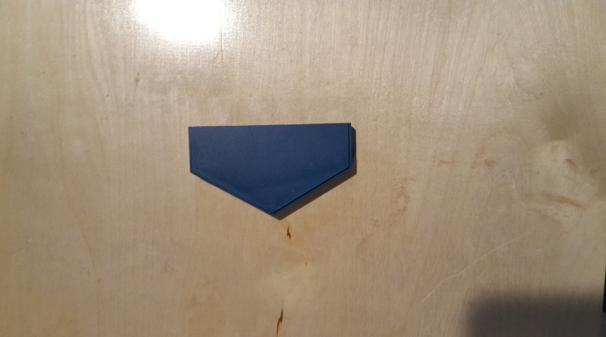 | ½ Hex Blocks – 40 pieces

Desert Hexes
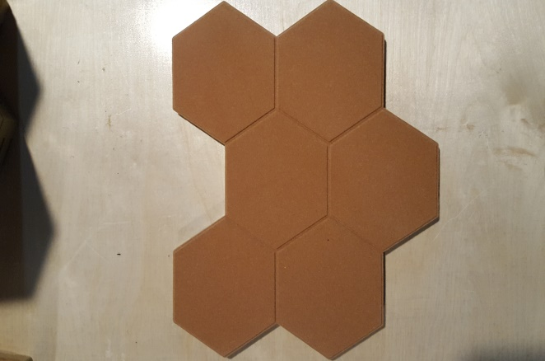 | 6 Hex Blocks – 83 pieces
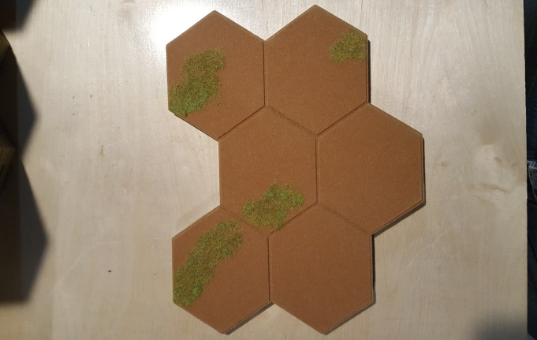 | 6 Hex Blocks w Grass - 43
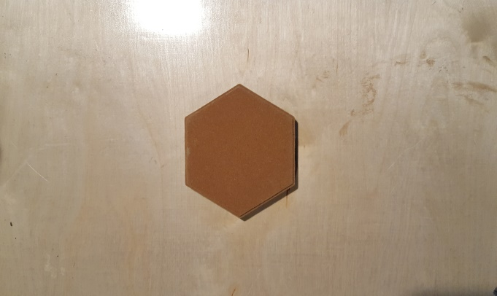 | 1 Hex Blocks - 19

Desert Overlay Terrain
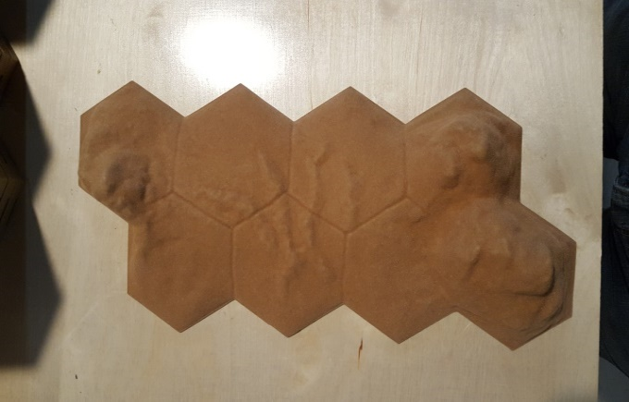 | 8 Hex Sloping/Mountains Hill - 2
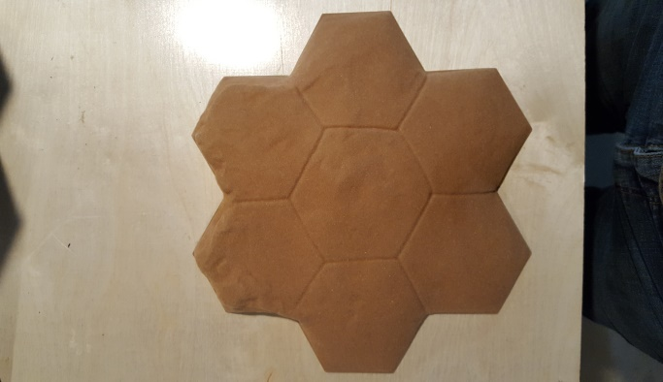 | 7 Hex Sloping Hill - 2
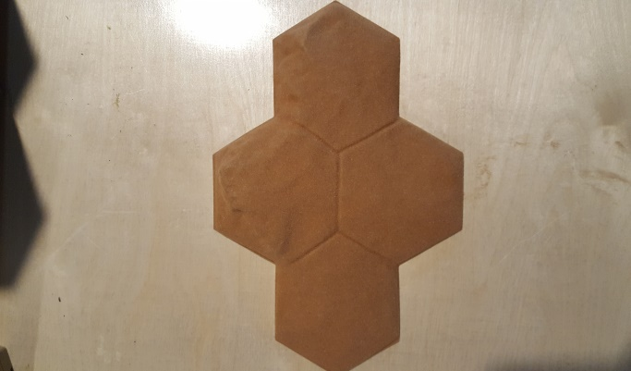 | 4 Hex Sloping Hill - 2
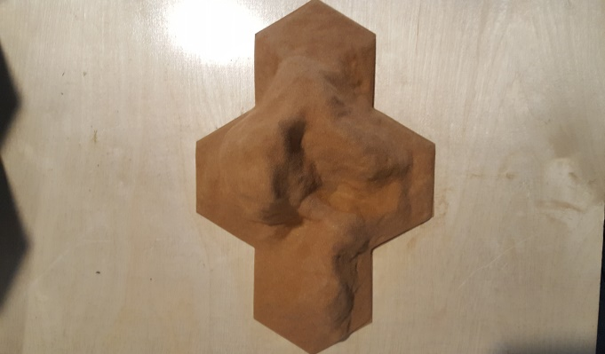 | 4 Hex Impassable Hill - 2
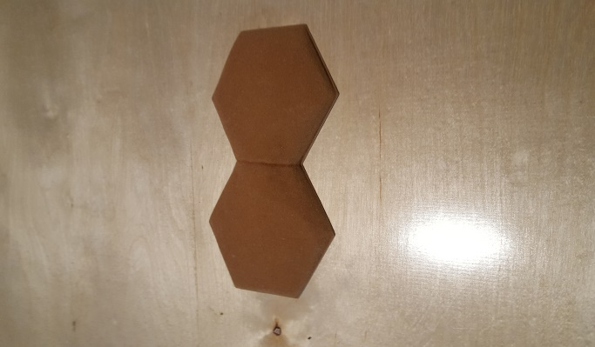 | 2 Hex Rises - 4
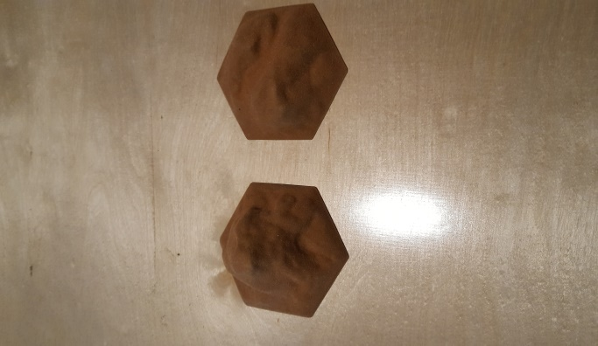 | 1 Hex Impassable Hill - 4
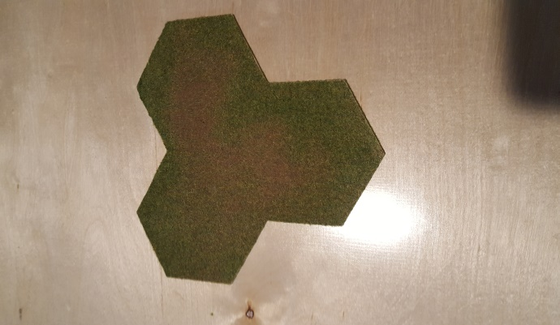 | 3 Hex Oasis - 2

Green Hexes
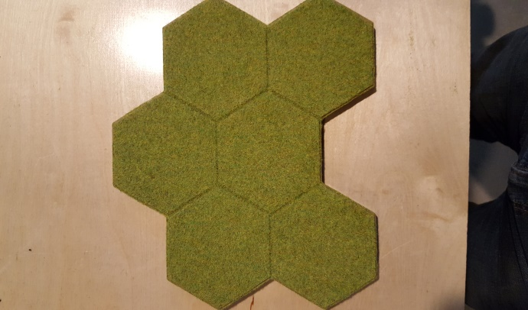 | 6 Hex Block Green Felt - 33
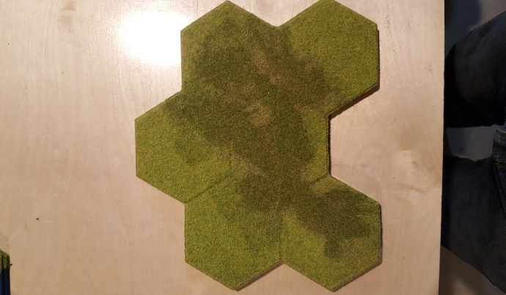 | 6 Hex Block Dark Green Felt - 33
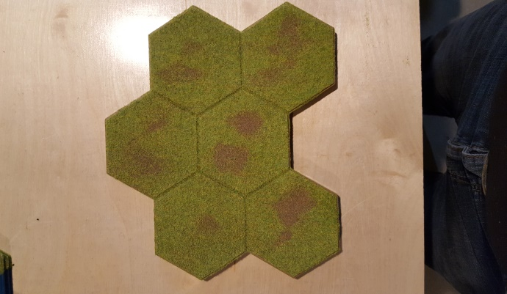 | 6 Hex Block Dirt Green Felt - 33
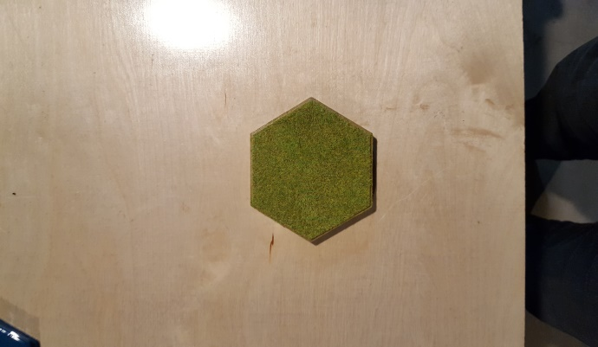 | 1 Hex Blocks Green Felt - 69
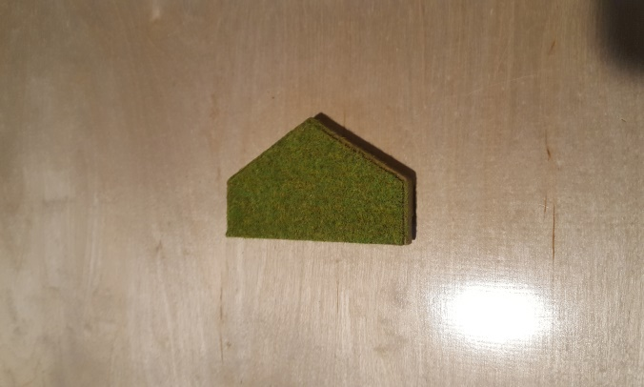 | 1/2 Hex Blocks Green Felt - 16
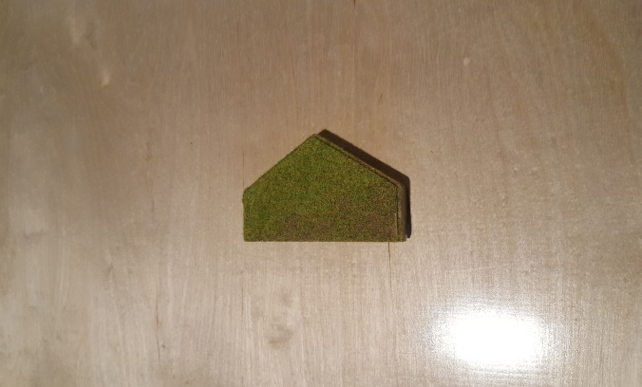 | 1/2 Hex Blocks Dark Green Felt - 14
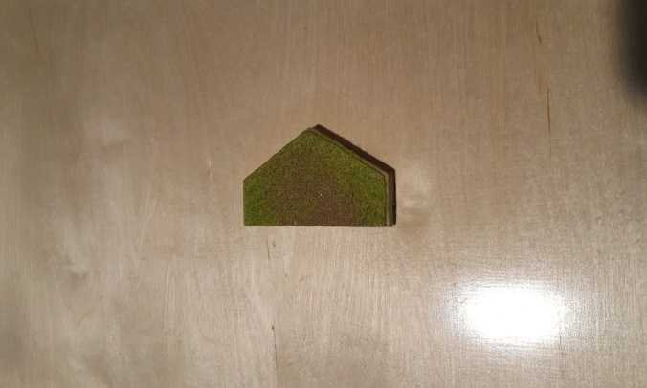 | 1/2 Hex Blocks Dirt Green Felt - 10

Road Hexes Overlays
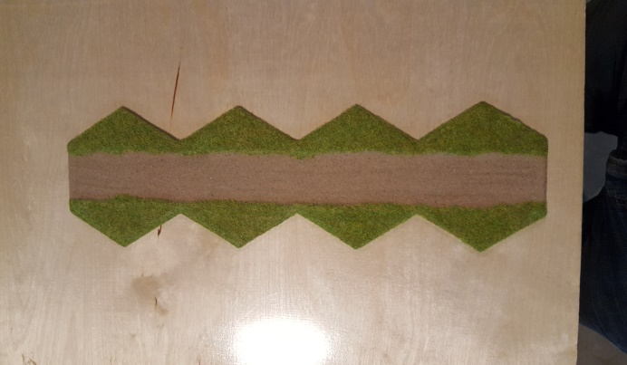 | 4 Hex Straight - 12
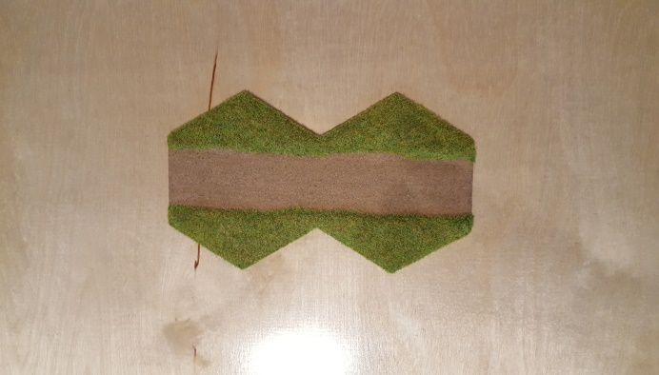 | 2 Hex Straight- 12
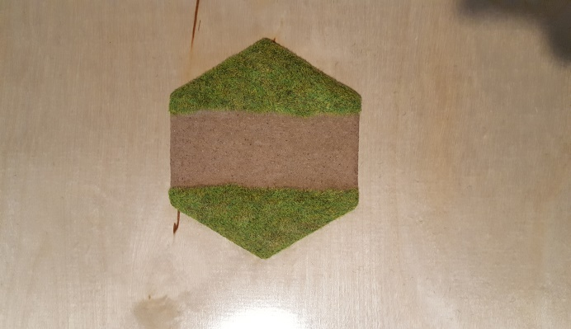 | 1 Hex Straight - 8
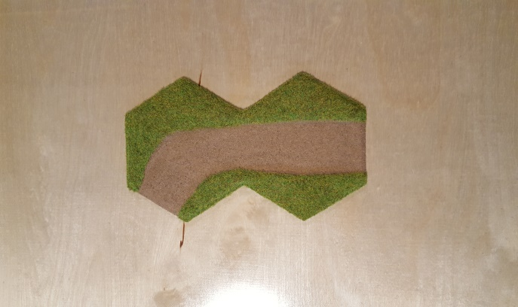 | 2 Hex Left Turn - 9
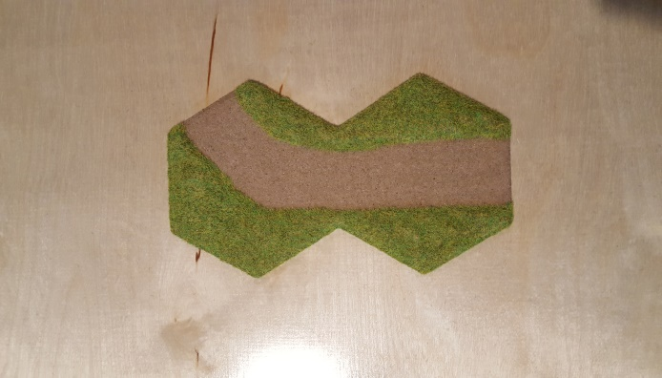 | 2 Hex Right Turn - 9
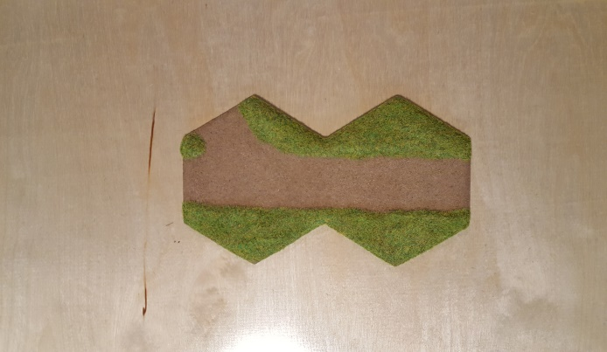 | 2 Hex Straight and Right Turn - 3
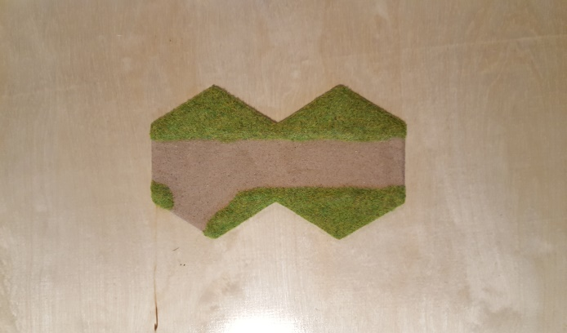 | 2 Hex Straight and Left Turn - 3
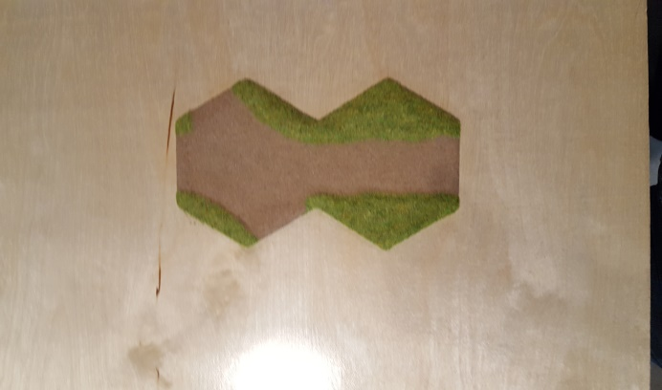 | 2 Hex Straight Double Turn - 3
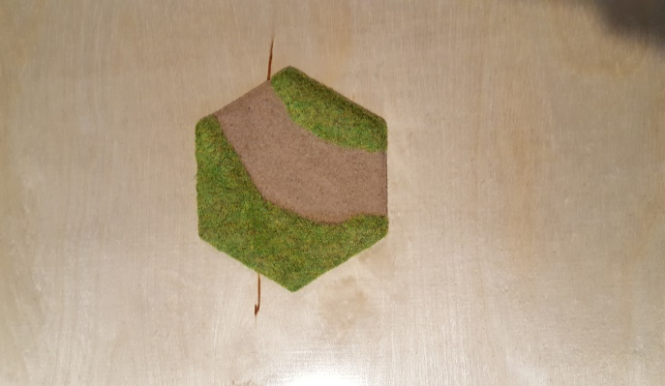 | 1 Hex Turn - 4
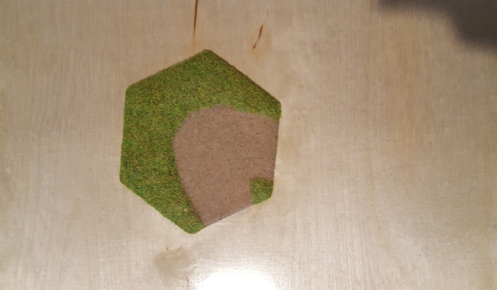 | 1 Hex U turn - 2
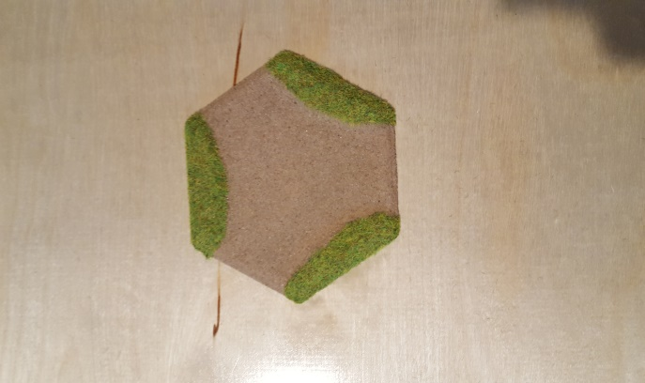 | 1 Hex Triple Turn -2

River Hexes Overlays
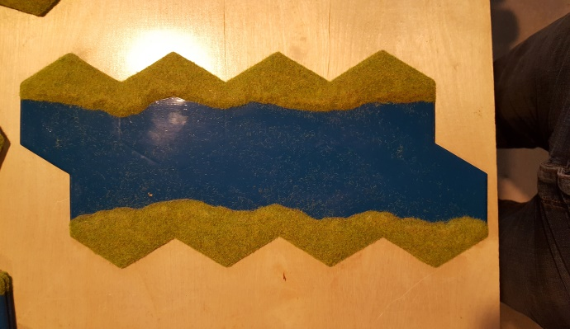 | - Hex Blocks - 3
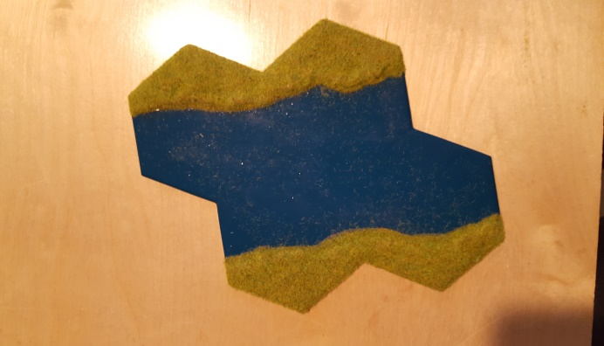 | 4 Hex Blocks - 3
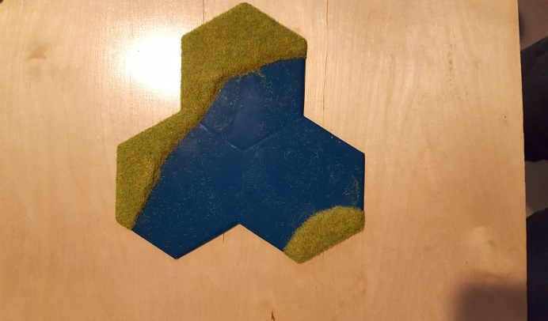 | 3 Hex Blocks - 3
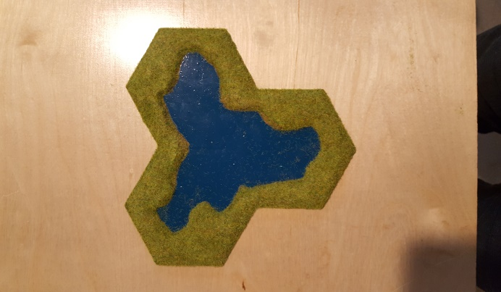 | 3 Hex Pond - 2

Green Felt Hills Overlay Hexes
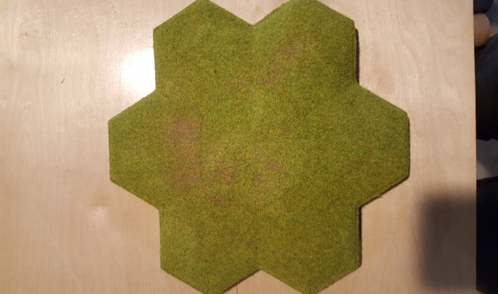 | 7 Hex Sloping Hil - 5
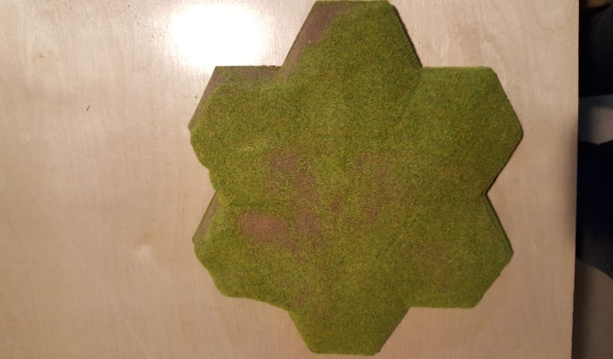 | 7 Hex Sharp Drop Hill - 3
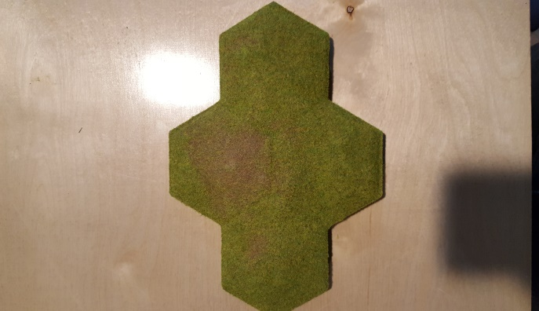 | 4 Hex Sloping Hill - 7
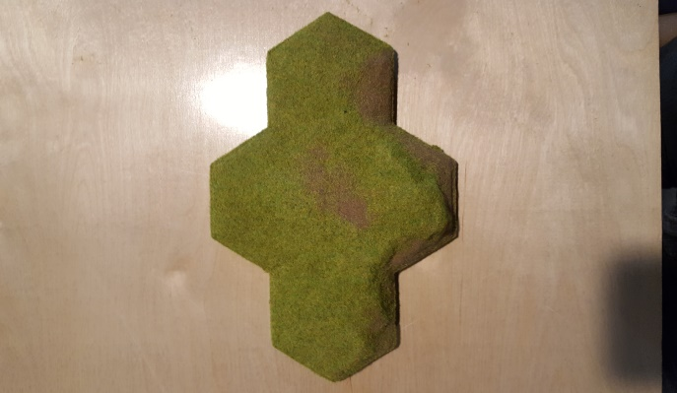 | 4 Hex Sharp Drop Hill - 7
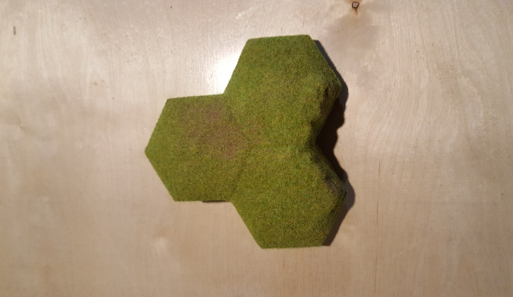 | 3 Hex Sharp Drop Hill - 3
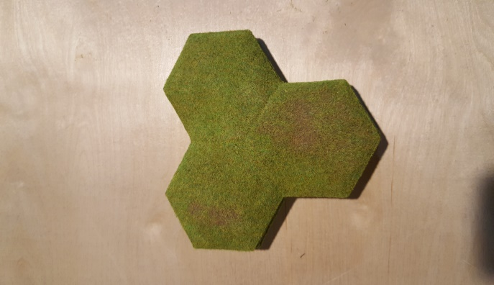 | 3 Hex sloping Hill - 3
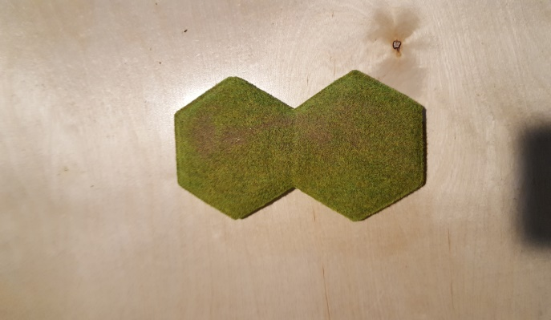 | 2 Hex Sloping Hill - 4

Mountains Overlay Hexes
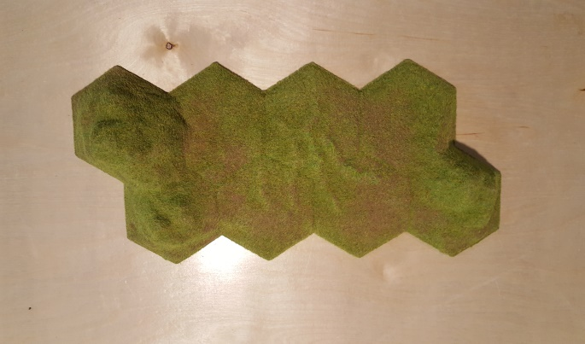 | 6 Hex Blocks Mountain/Sloping - 2
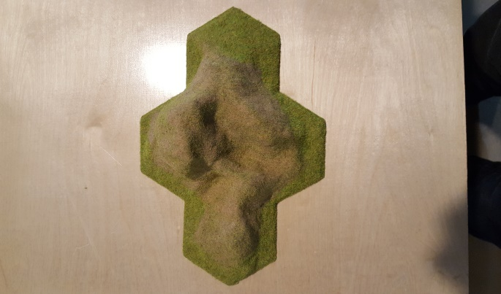 | 4 Hex Mountain - 3
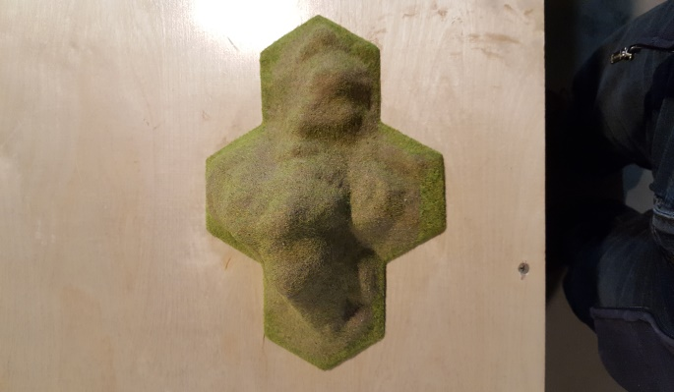 | 4 Hex Mountain - 3
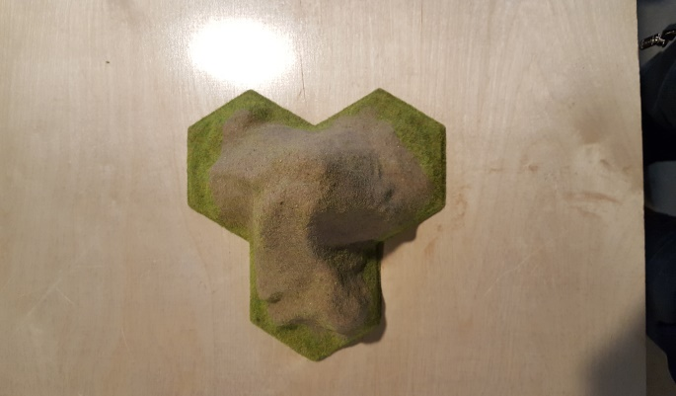 | 3 Hex Mountain - 3
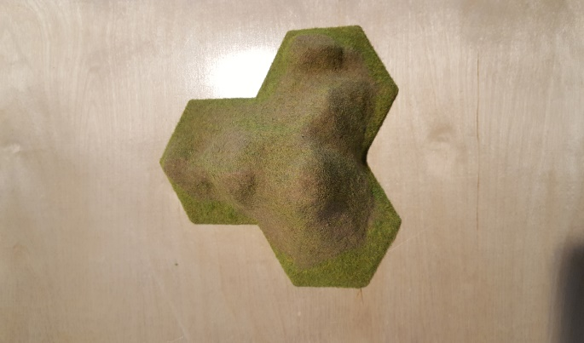 | 3 Hex Mountain - 3
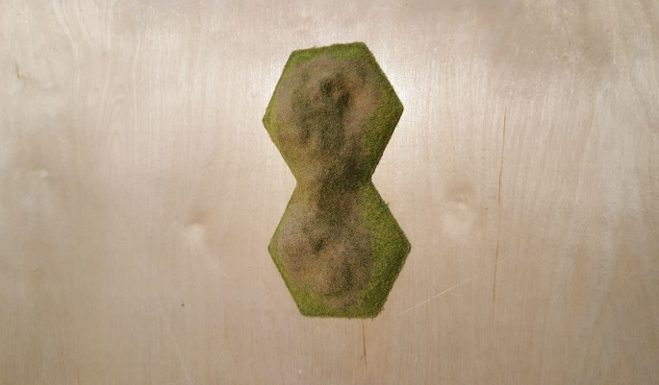 | 2 Hex Mountain - 7
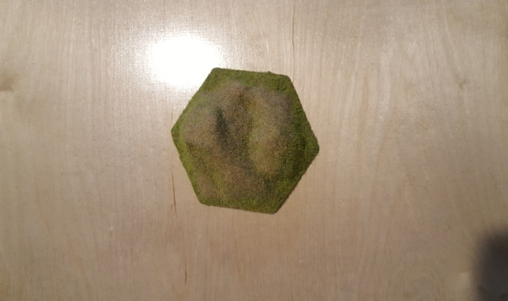 | 1 Hex Mountain - 2
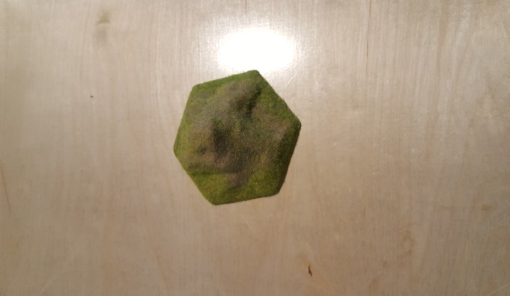 | 1 Hex Mountain - 2

1 Hex Sloping Terrain
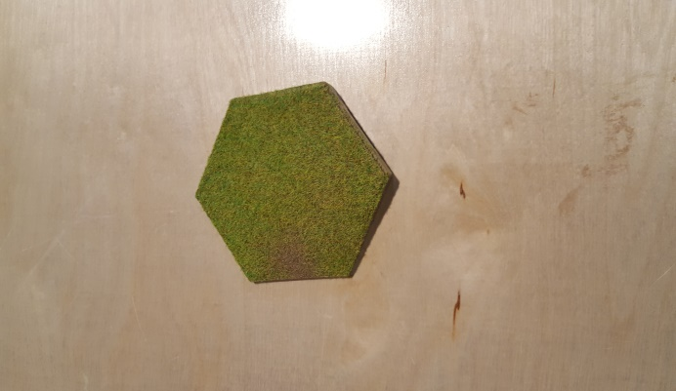 | 1 Hex A2 Blocks - 20
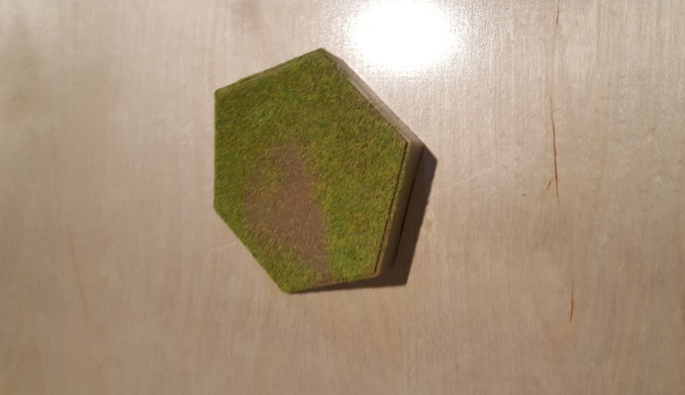 | 1 Hex B2 Blocks - 30
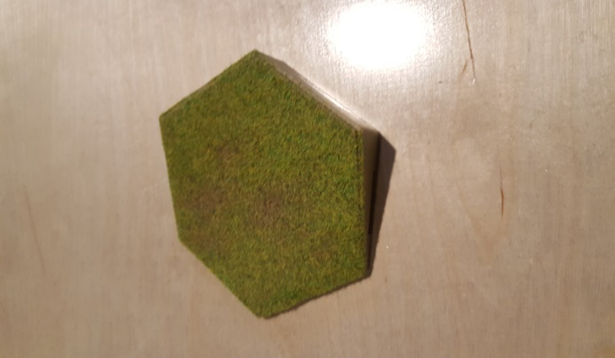 | 1 Hex C2 Blocks - 30
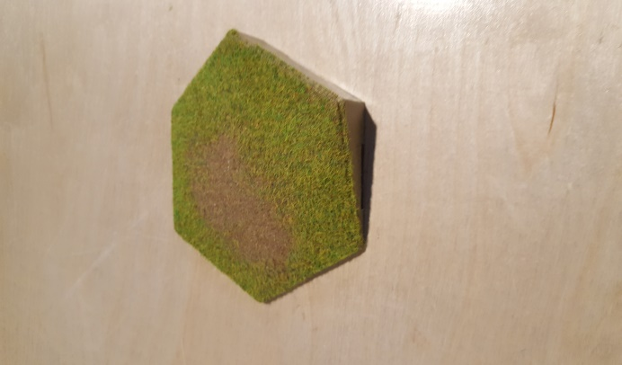 | 1 Hex no Letter Blocks - 32

Blank Hexes
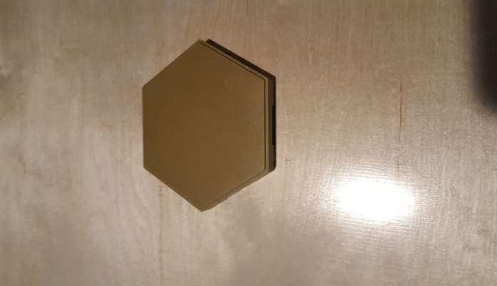 | 1 Hex Blocks - 7
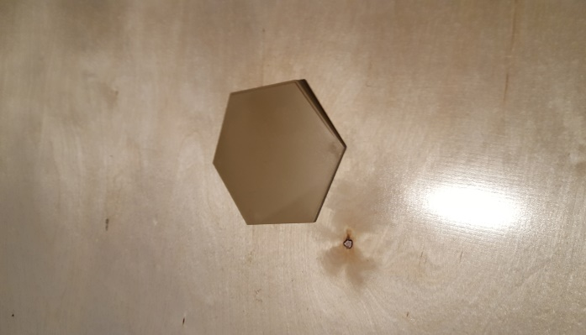 | 1 Hex Sloping - 3
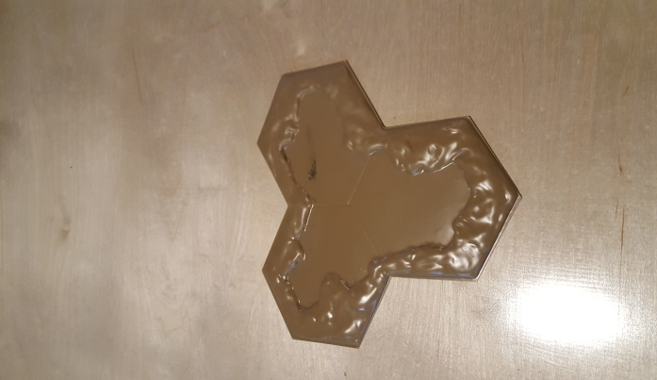 | 3 Hex Pond - 1

